**KARNATAK LAW SOCIETY’S**

**GOGTE INSTITUTE OF TECHNOLOGY**

**UDYAMBAG, BELAGAVI – 590008**

**(An Autonomous Institution under Visvesvaraya Technological University, Belagavi)**

**(Approved By AICTE, New Delhi)**

**DEPARTMENT OF INFORMATION SCIENCE AND ENGINEERING**

 

**DIGITAL ELECTRONICS**

RACHANA KAMPLI 2GI18IS032

LAXMI NYAMAGOUD 2GI18IS020

HEMANTH I T 2GI18IS015

ROHAN KOKATANUR 2GI18IS066

1. **Title**: Conveyor belt
2. **Problem Statement:**

An electric motor powering a conveyor used to move material is to be a material is present to be moved and if the protective interlock switch is not open. Input and output variables are to be expressed in binary. That is if operator 1 is in position then the associated variable is a logical 1. The motor is running (on) if its output control variable is a 1, and the motor is off if the variable is a 0.

1. **Objectives:**

1. A conveyor system is a common piece of mechanical handling equipment that moves materials from one location to another.

2. Conveyor systems allow quick and efficient transportation for a wide variety of materials, which make them very popular in the material handling and packaging industries.

3. Many kinds of conveying systems are available, and are used according to the various needs of different industries.

4. The purpose of the belt is to provide controlled movement of the product.

1. **Methodology:**

Variables a and b signify that the two operators are in position:

a. Operator 1 is in position

b. Operator 2 is in position

Let the motor variable be’ signified by M and the interlock switch be specified by s. If the interlock switch is closed, then s is true, 1. Let the material present variable be m.

M is the signal to turn the motor on and off, s means the interlock switch is closed m means material is present.

a, b, s and m are input variables.M is an output variable.

Because four input variables exist, we know that 16 combinations can occur;

24 =16.The truth table describing the input or output relationship is illustrated in the below table. To turn on the motor one of the two operators must be present, material must be present, and the interlock switch must be closed. Such a system may be found in any number of industrial environments. The actual control maybe implemented in any number of ways.

M=a’bms+ab’ms+abms

When either one or both of the two operators, represented by variables a and b, is present, material is present (m = 1), and the interlock switch is closed (s = 1), then the motor, represented by the output variable M, is started

**Truth Table:**

|  |  |  |  |  |
| --- | --- | --- | --- | --- |
| a | b | m | s | M |
| 0 | 0 | 0 | 0 | 0 |
| 0 | 0 | 0 | 1 | 0 |
| 0 | 0 | 1 | 0 | 0 |
| 0 | 0 | 1 | 1 | 0 |
| 0 | 1 | 0 | 0 | 0 |
| 0 | 1 | 0 | 1 | 0 |
| 0 | 1 | 1 | 0 | 0 |
| 0 | 1 | 1 | 1 | 1 |
| 1 | 0 | 0 | 0 | 0 |
| 1 | 0 | 0 | 1 | 0 |
| 1 | 0 | 1 | 0 | 0 |
| 1 | 0 | 1 | 1 | 1 |
| 1 | 1 | 0 | 0 | 0 |
| 1 | 1 | 0 | 1 | 0 |
| 1 | 1 | 1 | 0 | 0 |
| 1 | 1 | 1 | 1 | 1 |

1. **Implementation:**

The above obtained equation is implemented by using basic logic gates i.e. AND, OR and NOT**.**

**AND Gate**

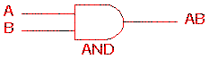 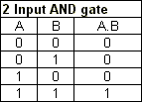

The AND gate is an electronic circuit that gives a **high** output (1) only if **all** its inputs are high.  A dot (.) is used to show the AND operation i.e. A.B.  Bear in mind that this dot is sometimes omitted i.e. AB.

**OR Gate**

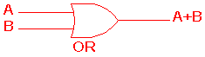 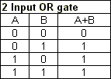

The OR gate is an electronic circuit that gives a high output (1) if **one or more** of its inputs are high.  A plus (+) is used to show the OR operation.

**NOT Gate**

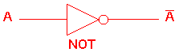 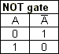

The NOT gate is an electronic circuit that produces an inverted version of the input at its output.  It is also known as an *inverter*.  If the input variable is A, the inverted output is known as NOT A.  This is also shown as A', or A with a bar over the top, as shown at the outputs. The diagrams below show two ways that the NAND logic gate can be configured to produce a NOT gate. It can also be done using NOR logic gates in the same way.

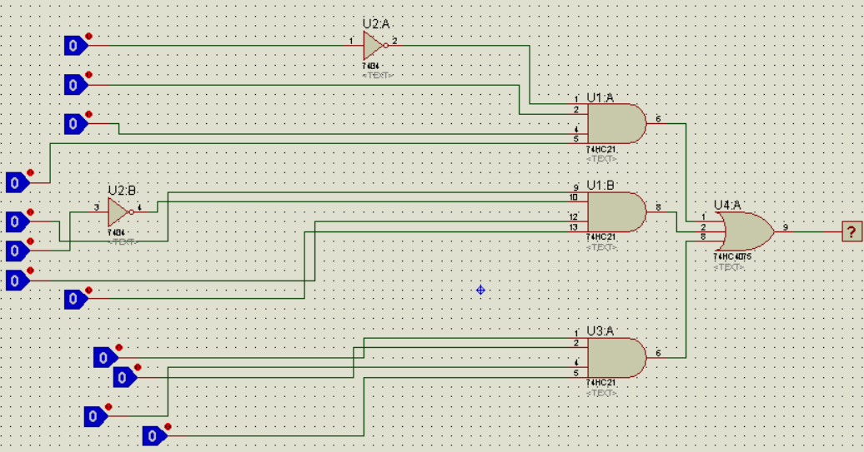

1. **Working Model Of Final Solution**

